**FORM DESIGN**

SUBMITTED BY: GEETHU BHASURAN

MCALE S3

ROLL NO: 25

1. LOGIN FORM

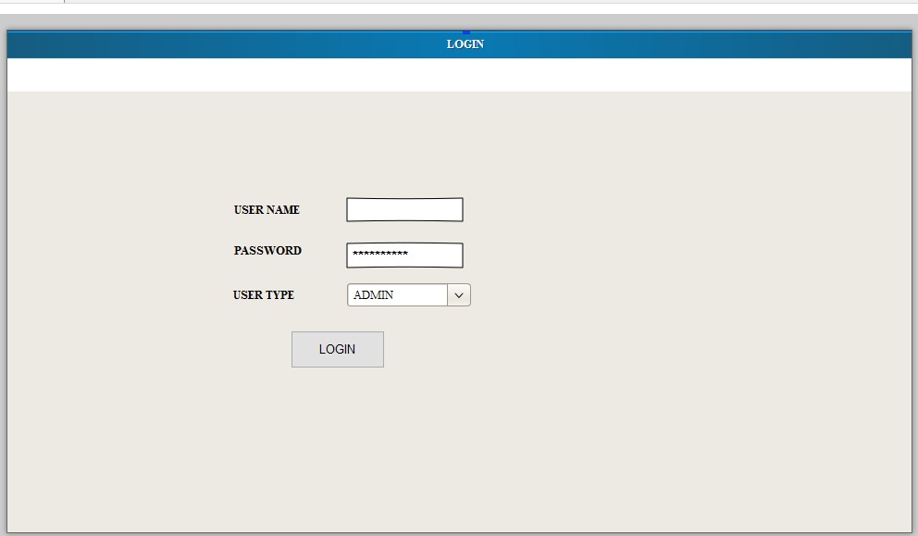

1. REGISTRATION

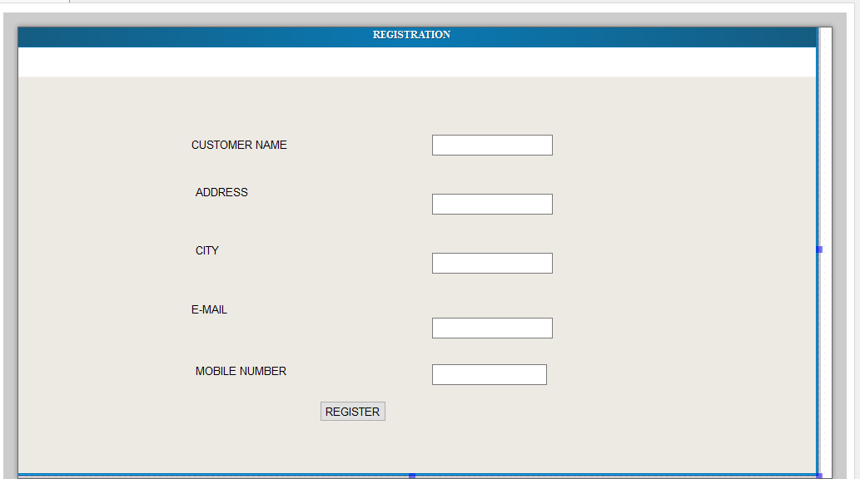

1. ADD ITEMS

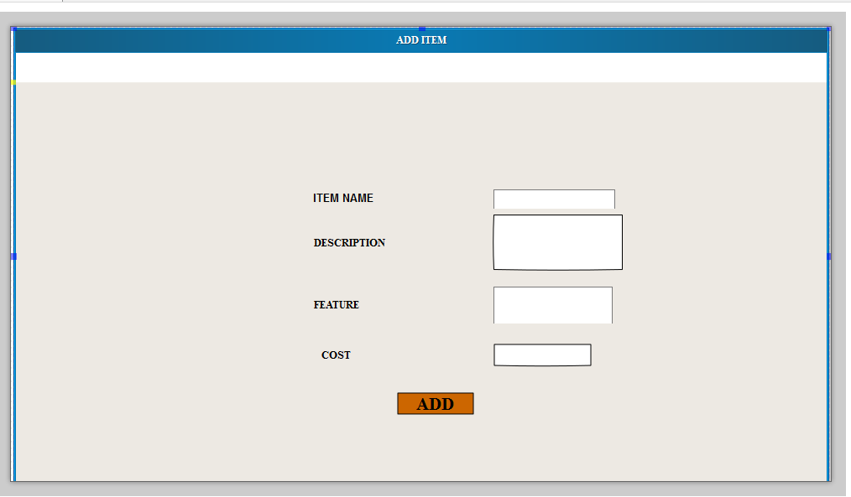

1. ADD HOSPITAL

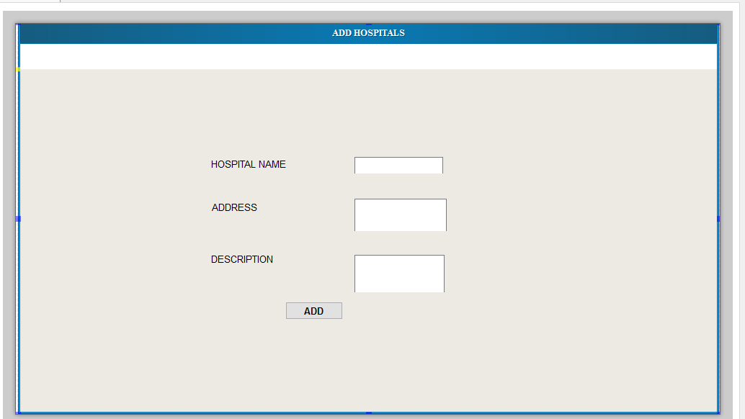

1. ADD SUPPLIERS

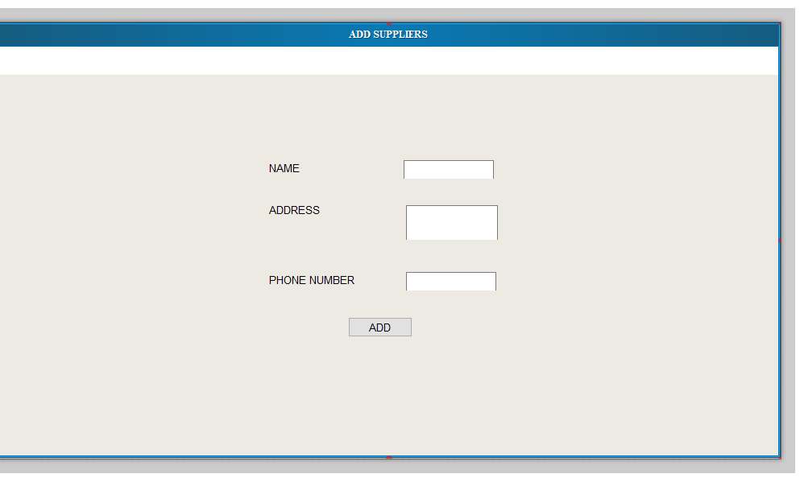

1. ADD TO CART

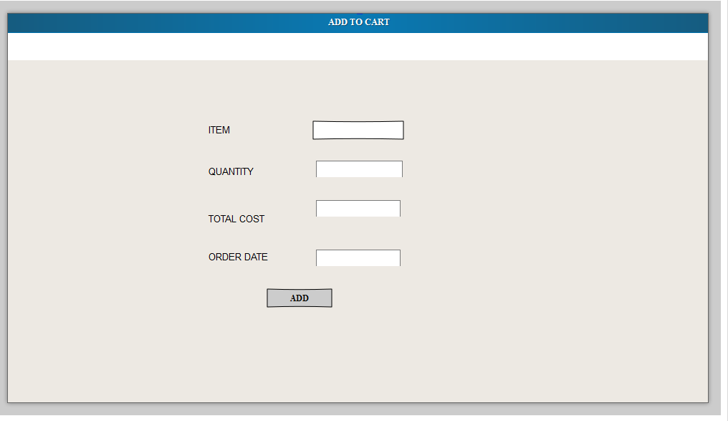

1. SELL ITEM

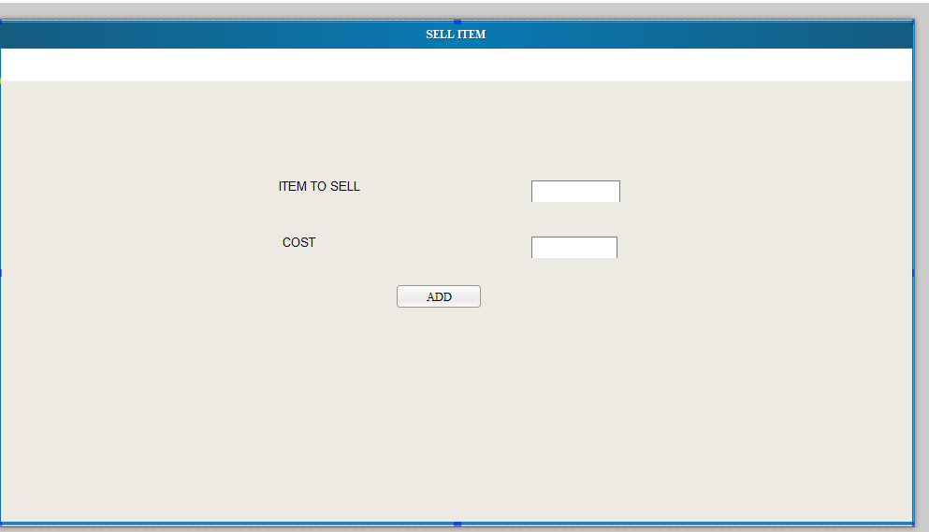

1. ADD FEEDBACK

